

Anekant Education Society's
Tuljaram Chaturchand College of Arts, Science and Commerce, Baramati (Empowered Autonomous).
Department of BBA (CA)
A Project report on
"Food Rescue Network”
Submitted in partial fulfilment of the requirements for the award of degree of
Bachelor of Business Administration (Computer Application)
Academic Year 2024-25
Submitted by
Mr. Atole Rohan Ashok
Seat No: - 3071
Mr. Pawar Aniket Vasant
Seat No: - 3099
Under the guidance of
Prof. R.D.Babar

Anekant Education Society’s
Tuljaram Chaturchand College of Arts, Science and Commerce, Baramati (Empowered Autonomous).
Department of BBA (C.A)

CERTIFICATE

Seat No: - 1) 3071
2) 3099 Date: -

This is to certify, that the project entitled “Food Rescue Network” Submitted by Mr. Atole Rohan Ashok and Mr. Pawar Aniket Vasant. In partial Fulfilment of the requirement of the award of degree BBA (C.A.) to Savitribai Phule Pune University, has been carried out by them under my guidance satisfactory during the academic year 2024-2025

Project Guide H.O.D

Internal Examiner External Examiner

ACKNOWLEDGEMENT

We are thankful to Dr. Avinash Jagtap sir, Principal of Tuljaram Chaturchand College, Baramati for making available all the required resources and co-operation in our project work.
We are thankful to Prof. M. R. Saste head of BBA (C.A) department, Tuljaram Chaturchand College, Baramati for making available all the required resources and co-operation in our project work.
It gives us great pleasure to express gratitude to Ms. R.D.Babar for her valuable guidance and suggestion while preparing this project.
I wish to express my sincere thanks to BBA (C.A) Department and all teaching and non-teaching staff. For their extraordinary help throughout the period of my project. We are especially thankful to those who helped us directly-indirectly in completion of this work successfully.

Place: Baramati Name: Mr. Atole Rohan Ashok
Date: Seat No.3071

Name: Mr. Pawar Aniket Vasant
Seat No.3099
INDEX

Sr.  No |  | Contents | Page.  No
1 |  | Project Title | 6
 | 1.1 | Introduction | 7
 | 1.2 | Existing System | 9
 | 1.3 | Proposed System | 10
 | 1.4 | Scope of System | 11
 | 1.5 | Software and Hardware Requirements | 12
 | 1.6 | Modules | 13
2 |  | System Analysis | 14
 | 2.1 | Fact Finding Technique | 15
 | 2.2 | Feasibility Study | 19
3 |  | System Design | 21
 | 3.1 | E-R Diagram | 22
 | 3.2 | Context Level Diagram | 23
 | 3.2.1 | DFD (Level 0) | 24
 | 3.3 | Use Case Diagram | 25
 | 3.3.1 | Use Case Diagram (Admin) | 26
 | 3.3.2 | Use Case Diagram (User) | 27
 | 3.4 | Class Diagram | 28
 | 3.5 | Object Diagram | 29
 | 3.6 | Activity Diagram | 30
 | 3.7 | Sequence Diagram | 31
 | 3.7.1 | Sequence Diagram for donor | 31
 | 3.7.2 | Sequence Diagram for Admin | 32
 | 3.8 | Collaboration Diagram | 33
 | 3.9 | Component Diagram | 34
 | 3.10 | Deployment Diagram | 35
4 |  | Data Dictionary | 35
5 |  | Design Of Inputs | 42
6 |  | Report | 50
7 |  | Conclusion | 54
8 |  | Future Enhancement | 55
9 |  | Bibliography | 56
10 |  | Sample Code… | 57

1.Project Title

“Food Rescue Network”

INTRODUCTION
  - Introduction

Food Donation is a mission to end hunger and no waste of food to make a hungry-free world. According to the latest survey, 1.3 billion tons of food is thrown as waste every year. Additionally, one-third of the food consumed is stated as leftovers.

The focus of this project is to reduce the amount of food wasted and being used for needy people. Therefore, a website is developed by which a person can donate food with their capacity, and at the same time, the application lets the organization put their request on their requirements.

Our mission is to bridge the gap between surplus food and hunger by rescuing edible food from various sources and delivering it to community organizations that support individuals and families in need. By doing so, we aim to significantly reduce food waste, mitigate environmental impacts, and enhance food security within our communities.

1.2. Existing System

- Presently people who wish to donate surplus food need to personally visit the organizations and donate foods or other items.

- Manual processes and limited technology support are typical of the current food waste management and donation system.

- Traditional methods of connecting and coordinating food donations include phone calls, physical visits or word of mouth.

- If they do not need the food, then the person has to contact another organization. This makes the donor tired and exhausted.

- Increased food waste and financial losses can be caused by this manual approach.

1.3. Proposed System

- The website for food donation acts as an interface between the users looking for a channel to give the excess food without wasting it.

- It enables us to donate the excess food by notifying nearby users with the details of the available food.

- The donor’s information is posted on the application and any number of users can claim the food.

- The system is designed so that one or more users can claim the food.

- The food serving process is based on priority (first come first serve).

- Methods of connecting and coordinating food donations is one click from our website.

1.4. Scope of System

- According to the research, people are attempting to donate
food more frequently through Food Rescue Network Website because they are quicker and save time compared to searching multiple websites for non-proﬁt contact information.

- Additionally, we want to grow our project by adding more platforms and contacting delivery services to pick up food, among other things.

- The ability to view the real-time location of food deliveries is another feature that raises expectations.

- In order to streamline, our system will provide a quicker booking procedure and a quicker reaction to user requests, saving the user time.

1.5. Software and Hardware Requirements

Software Requirements –

Operating System | WINDOWS OS (Windows 10, 11)
Frontend | HTML5, CSS, Bootstrap5, JavaScript
Backend | MySQL, PHP

Hardware Requirements –

Processor | Intel inside CORE i5 Processor and Above
RAM | 8 GB and ROM 512 GB
Hard Disk | 500 GB

1.6 Modules

- Sign-up and log in: The user has to sign in with the name, email ID, contact number, and address.

- Donating the surplus food: The user has to choose the activity if donating or claiming the surplus food. It is required to fill the contact address where the food is available.

- Claiming the surplus food: If the user claims for the surplus food, need to specify the organization name with address and contact details.

- Priority-based sorting: If one or more user has claimed for food, the request is scheduled on priority bases.

- Data Analysis with Graphs: The data gets recorded after every donation and the graph is prepared for visualization impact. This graph is prepared with the focus of increasing donating in the minds of people.

- Data Analysis with Reports: Once the data gets recorded, the system generates reports with the total number of people fed and the total quantity of food donated.

2. SYSTEM ANALYSIS
  - Fact Finding Technique

At the time of the analysis of the system or before starting the actual work of the system the system analyst has to collect information about the manual system from the user department for which the system will be developed. To collect this information, the system analyst prefers anyone of the following fact-finding technique or prefers two or more fact-finding techniques according to the situation:
1. Examining Documentation:
- Project proposal: "Food Rescue Network: Reducing Food Waste and Feeding the Hungry"
- Project plan: Outlines goals, objectives, timelines, and resources required
- Meeting minutes: Notes from meetings with stakeholders, including food donors, recipient organizations, and volunteers
- Reports: Monthly reports on food rescue metrics, including pounds of food rescued, number of meals provided, and demographics of recipients.
2. Interviews
- Food Donors:
- What motivates you to donate food to the Food Rescue Network?
- What types of food do you typically donate?
- How do you currently handle surplus food?
Recipient Organizations:
- How do you currently receive food from the Food Rescue Network?
- What types of food do you need most?
- How do you distribute food to those in need?
- Volunteers:
- What motivates you to volunteer with the Food Rescue Network?
- What tasks do you typically perform as a volunteer?
- How do you think the Food Rescue Network could improve?

3. Observation

- Food Rescue Operations:
- Observe food pickup and delivery processes
- Note efficiency and effectiveness of operations
- Identify areas for improvement
- Recipient Organizations:
- Observe food distribution processes
- Note effectiveness of food distribution
- Identify areas for improvement

4. Research

- Food Waste Statistics:
- Research national and local statistics on food waste
- Identify trends and patterns
- Food Insecurity Statistics:
- Research national and local statistics on food insecurity
- Identify trends and patterns
- Best Practices:
- Research best practices in food rescue and distribution
- Identify innovative solutions and technologies

5. Questionnaires

- Food Donor Questionnaire:
- What types of food do you typically donate?
- How often do you donate food?
- What motivates you to donate food?
- Recipient Organization Questionnaire:
- What types of food do you need most?
- How often do you receive food from the Food Rescue Network?
- How do you distribute food to those in need?
- Volunteer Questionnaire:
- What motivates you to volunteer with the Food Rescue Network?
- What tasks do you typically perform as a volunteer?
- How do you think the Food Rescue Network could improve?

2.2. Feasibility Study

  - A feasibility study is a preliminary exploration of a proposed project or undertaking to determine its merits and viability.

- A feasibility study is an assessment of the practicality of a project or system.

- A feasibility study is an assessment that determines the likelihood of a proposed project being successful, such as a new product line or technical system.

Types of feasibility studies

1. Technical feasibility
2. Economic feasibility
3. Operational feasibility

- Technical Feasibility

- Analyze the technical skills and capabilities of software development team member.

- Determine if the relevant technology is stable and established.
2 .Economic Feasibility

- The costs incurred in software development generate long-term benefits for an organization.

- Costs required to conduct a complete software study (e.g., requirements extraction and requirements analysis).

- Hardware, software, development team, and training costs.

3 .Operational Feasibility

- Determine if the expected issue in the user request is a high priority.

- Determine if the organization is satisfied with alternative solutions proposed by the software development team.

- Determine if the solution proposed by the software development team is acceptable.

- Analyze whether users are comfortable with new software.

3. SYSTEM DESIGN

3.1. ER Diagram:

Login
has
Donor
Donate
Food
Accept
View
History
View
Charity
Collect
Assign Food
Admin
Manage
Donor Record
ID
Password
Name
Addr
Gmail
Type
Quantity
Name
Category
Day
Quantity
Date
Name
Addr
Gov Res No
Username
Password
Delete
Update
1
1
1
1
M
1
1
1
M
1
M
1
M
1
M
1
M
M

  - Context level diagram:

Food Rescue Network
0.0
Donor
Admin
Charity
Report
Donate Food
Request to History
Store Details
Show History
Store Details
Give Details
Give Details
Assign Food
Request to donor Details
Request to report
Donor

Admin

Charity

Report

    - DFD:
Donor

Register
1.0

2.0
Login

3.0
Donate

4.0
History

5.0
Report
Request to register
Response
Add Details
Request to login
Response valid
Donate Food
Donate successfully
view
Display details
Response
Check Details
Response
Add Details
Response
Check Details
Response
Details
Details
Details

Donor

Food

History

Donor
Food
History

  - Use Case Diagram for Admin and Donor:

Register
Login
Edit Profile
Donate Food
Donate Money
View History
Feedback
Report
Logout
Admin
Donor

    - Use Case for Admin:

Login
Edit Profile
View History
Report
Logout
Admin

    - Use Case for Donor:

Register
Login
Edit Profile
Donate Food
Donate Money
View History
Feedback
Logout
Donor

  - Class Diagram:

Admin
Charity
Donor
Donate
Food
A_name
A_phno
A_email
C_name
C_phno
C_email
D_name
D_phno
D_email
Donate_Id
Address
Food_Name
F_name
F_category
F_date
F_quentity
Login()
Assignfood()
Logout()

Login()
Takefood()
Logout()

Login()
Donatefood()
Logout()

View()
View()

1
1
1
*
*
*
*
*
  - Object Diagram:-

Admin
Charity
Donor
Donate
Food
A_name=”ram”
A_phno=”77698753”
A_email=”ram@gamail.com
C_name=”tata trust”
C_phno=”76876767”
C_email=”tata@gmail.com”
D_name=”Aniket”
D_phno=”8345606”
D_email=”ap@gamil.com”
Donate_Id=”1”
Address=”Baramati”
Food_Name=”rice”
F_name=”rice”
F_category=”coocked”
F_date=”10/08/2024”
F_quantity=”10KG”
1
1
*
*
*
*

*
1
  - Activity Diagram:

Start
Admin
Donor
Login
Check
Edit Profile
Generate Report
Assign Food
Register
Login
Check
Edit Profile
Donate food
Donate food
View History
Charity
Register
Login
Invalid
Check
Edit Profile
View History
Invalid
Invalid
valid
valid
valid
Print Report
Logout

End
  - Sequence diagram:

    - Sequence diagram for Donor:
Donor
Web browser

Web server
Database server

X
X
X
X
1.1 Enter Registration Details()
1.2 Send Details( )
1.3 Add Details ( )
1.4 Response( )
1.5 Response (valid )
1.6 Registration Successfully
2.1 Enter Login Details()
2.2 Send Details( )
2.3 Check Details( )
2.4 Response( )
2.5 Response (valid )
2.6 Login Successfully
3.1 Donate Food ()
3.2 Send Details( )
3.3 Add Details ( )
3.4 Response( )
3.5 Response (valid )
3.6 Donate Food Successfully
4.1 Logout ()
4.2 Logout Successfully

    - Sequence Diagram for Admin:
Admin
Web browser

Web server
Database server

X
X
X
X
1.1 Enter Login Details()
1.2 Send Details( )
1.3 Check Details ( )
1.4 Response( )
1.5 Response (valid )
1.6 Login Successfully
2.1 Assign Food ()
2.2 Send Details( )
2.3 Add Details( )
2.4 Response( )
2.5 Response (valid )
2.6 Assign Food Successfully
3.1 Edit Profile ()
3.2 Send Details( )
3.3 Add Details ( )
3.4 Response( )
3.5 Response (valid )
3.6 Edit profilr Successfully
4.1 Logout ()
4.2 Logout Successfully

  - Collaboration Diagram:

Food
Donor
Charity
Login
2.1. Donate
2.2. Donated Successful
7.1. Collect Food
1.1.Request to Login
1.2. Login Successful
7.2. Food Received
4.1.Verify Food
4.2. Food (Accept/Reject)
5.1. Assign Food
3.2. Login Success
3.1. Request To Login
6.2. Login Success
6.1. Login Request
5.2. Received Successful
Admin

  - Component Diagram:

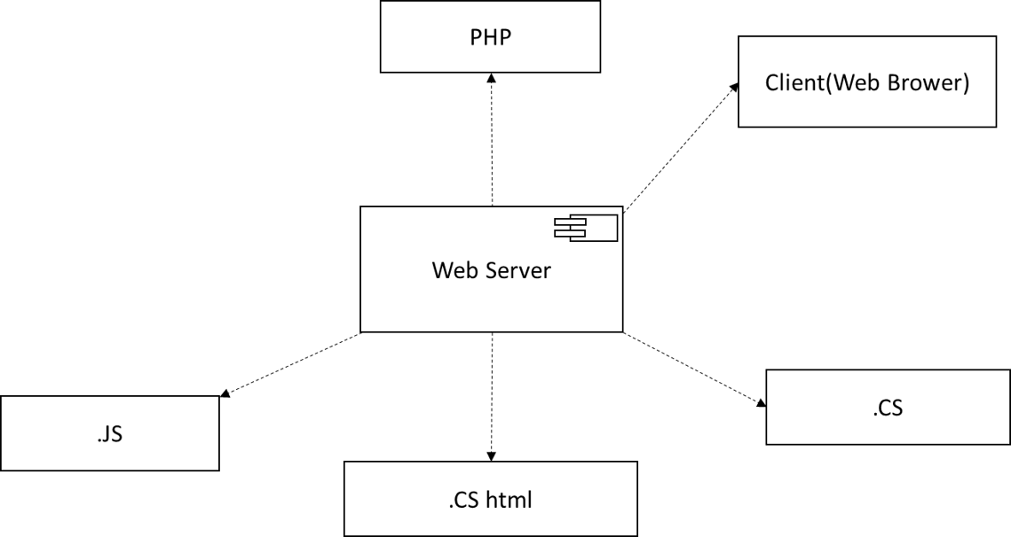

  - Deployment Diagram:

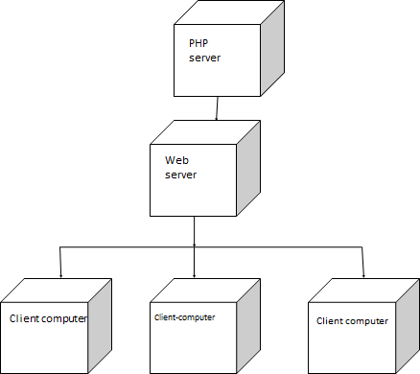

4. Data Dictionary

Sr. No | Field Name | Data Type | Constraint | Field Length | Description
1 | admin_id | INT | PRIMARY KEY | - | Unique identifier for the admin
2 | username | VARCHAR | NOT NULL | 50 | Admin's username
3 | password | VARCHAR | NOT NULL | 100 | Admin's password
4 | email | VARCHAR | NOT NULL | 100 | Admin's email address
1. Admin:

2. Donor:

Sr. No | Field Name | Data Type | Constraint | Field Length | Description
1 | donor_id | INT | PRIMARY KEY | - | Unique identifier for the donor
2 | name | VARCHAR | NOT NULL | 100 | Donor's name
3 | email | VARCHAR | NOT NULL | 100 | Donor's email address
4 | phone | VARCHAR | NOT NULL | 20 | Donor's phone number
5 | address | VARCHAR | NOT NULL | 200 | Donor's address

3. Charity:
Sr. No | Field Name | Data Type | Constraint | Field Length | Description
1 | charity_id | INT | PRIMARY KEY | - | Unique identifier for the charity
2 | name | VARCHAR | NOT NULL | 100 | Charity's name
3 | email | VARCHAR | NOT NULL | 100 | Charity's email address
4 | phone | VARCHAR | NOT NULL | 20 | Charity's phone number
5 | address | VARCHAR | NOT NULL | 200 | Charity's address

4. Contact Us:

Sr. No | Field Name | Data Type | Constraint | Field Length | Description
1 | Contact_id | INT | Primary Key | - | Unique identifier for the history record
2 | Email | VARCHAR | NOT NULL | 100 | Email for user
3 | Subject | VARCHAR | NOT NULL | 100 | Subject for contact us
4 | message | VARCHAR | NOT NULL | 200 | Message for Admin

5. Food:

Sr. No | Field Name | Data Type | Constraint | Field Length | Description
1 | food_id | INT | PRIMARY KEY | - | Unique identifier for the food item
2 | name | VARCHAR | NOT NULL | 100 | Name of the food item
3 | category | VARCHAR | NOT NULL | 50 | Category of the food item
4 | expiration | DATE | NOT NULL | - | Expiration date of the food item
5 | quantity | INT | NOT NULL | 50 | Quantity of the food item

- Design of Inputs

- Home/Index page:

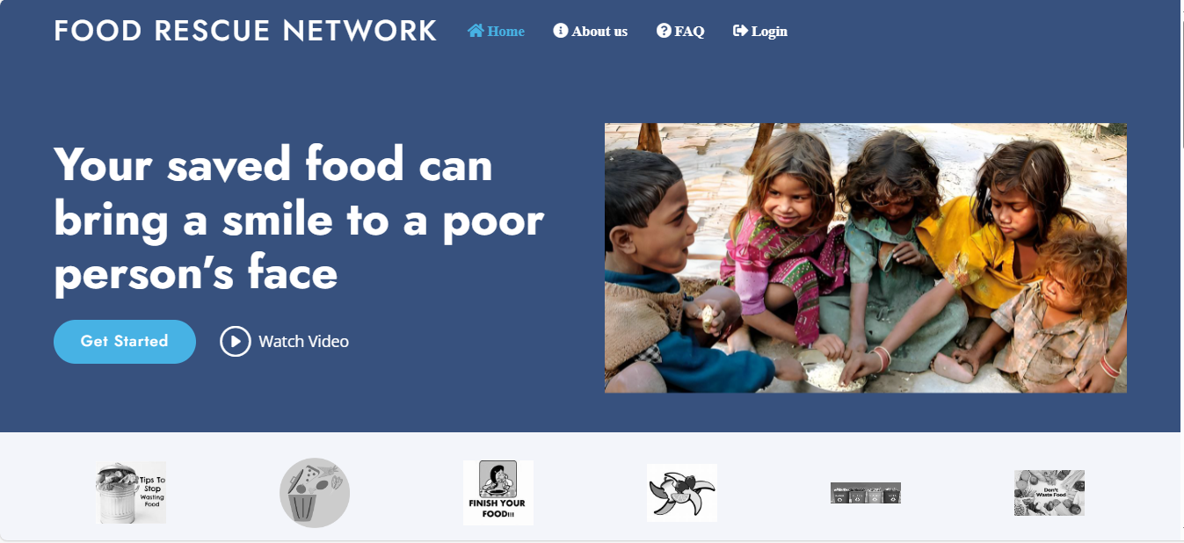

- Donor Login:

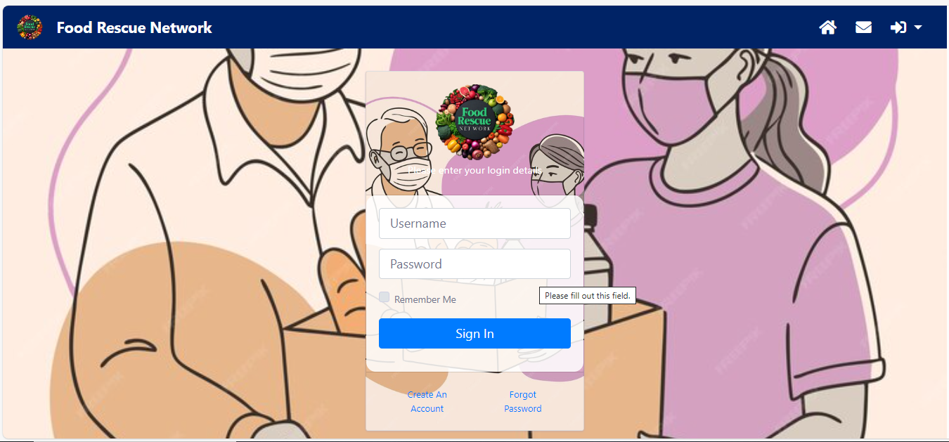

- Donor Dashboard:

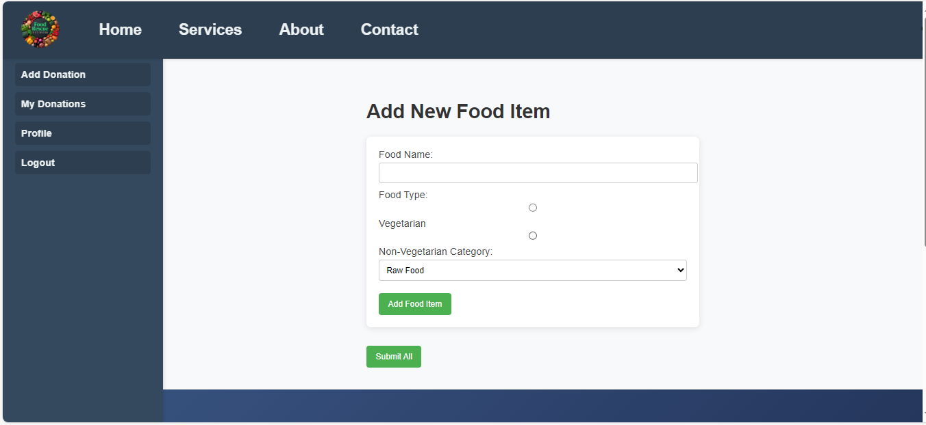

- Charity Login:

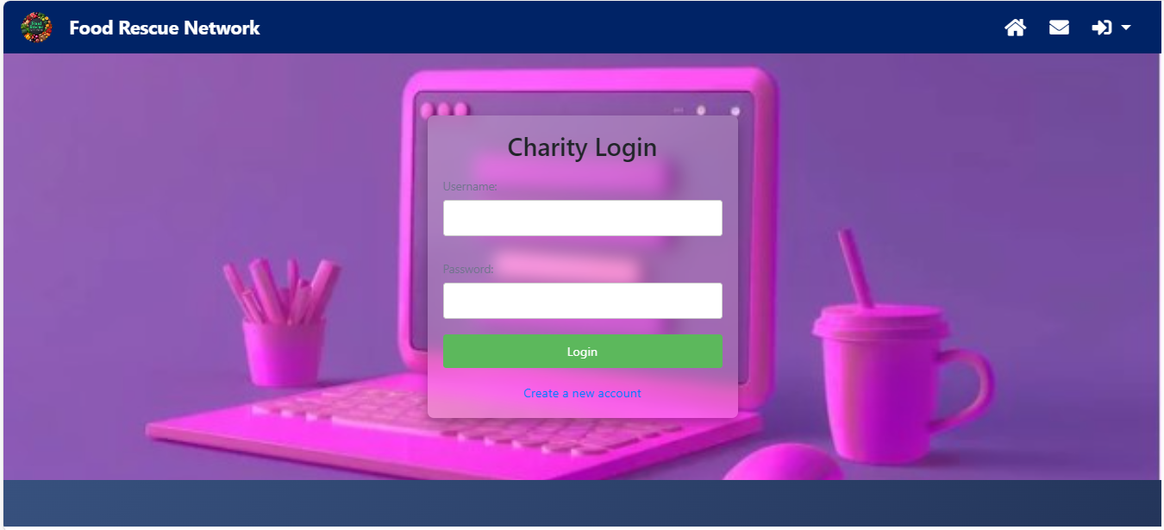

- Charity Dashboard:

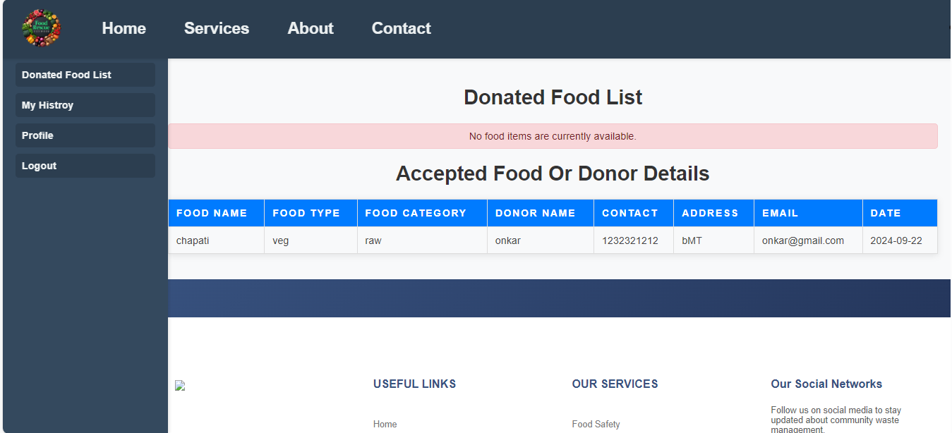

- Admin Login:

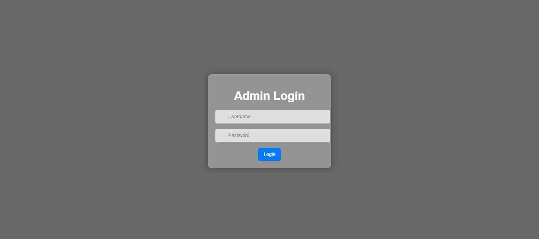

- Admin Dashboard:

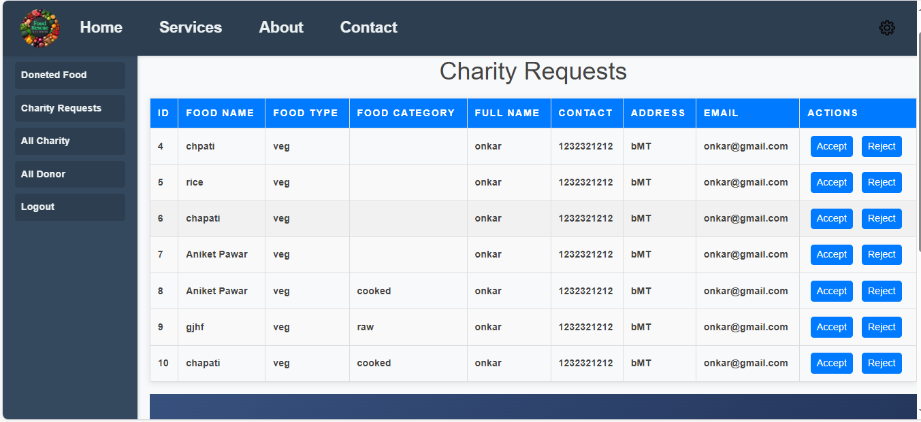

- Charity Request in Admin:

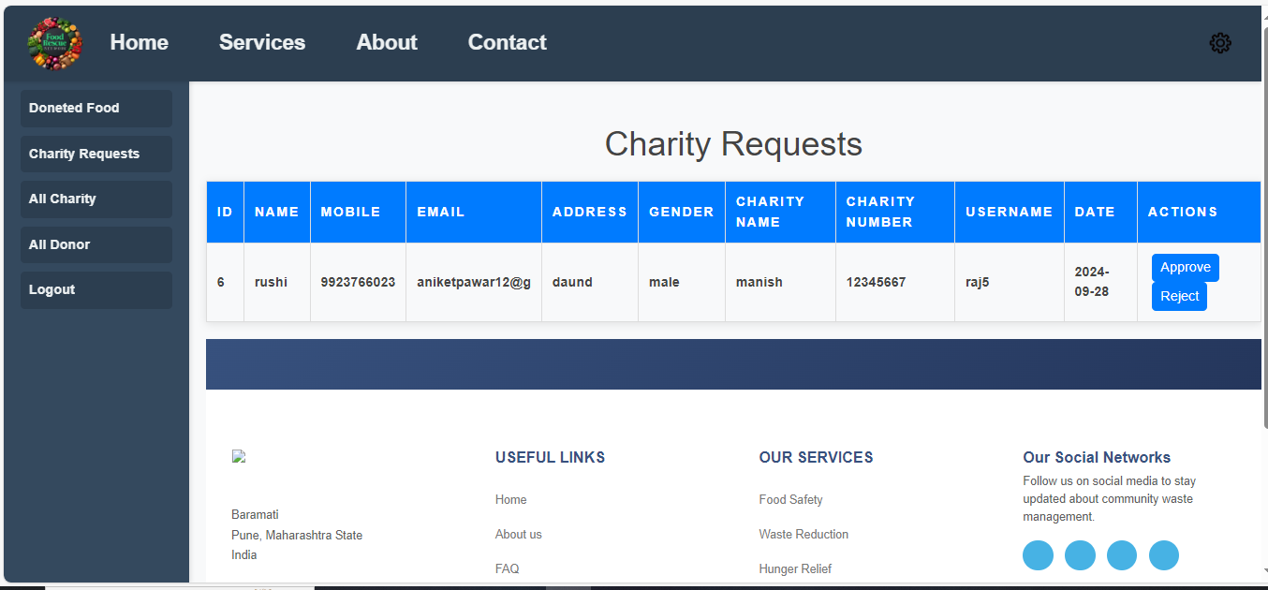

6. Reports

- Food Donation Report:

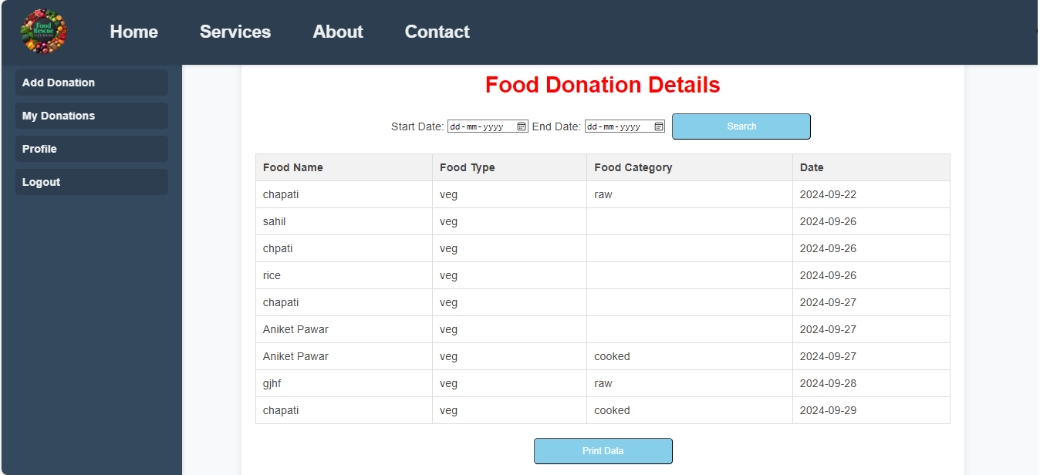
- Donated Food in Charity:

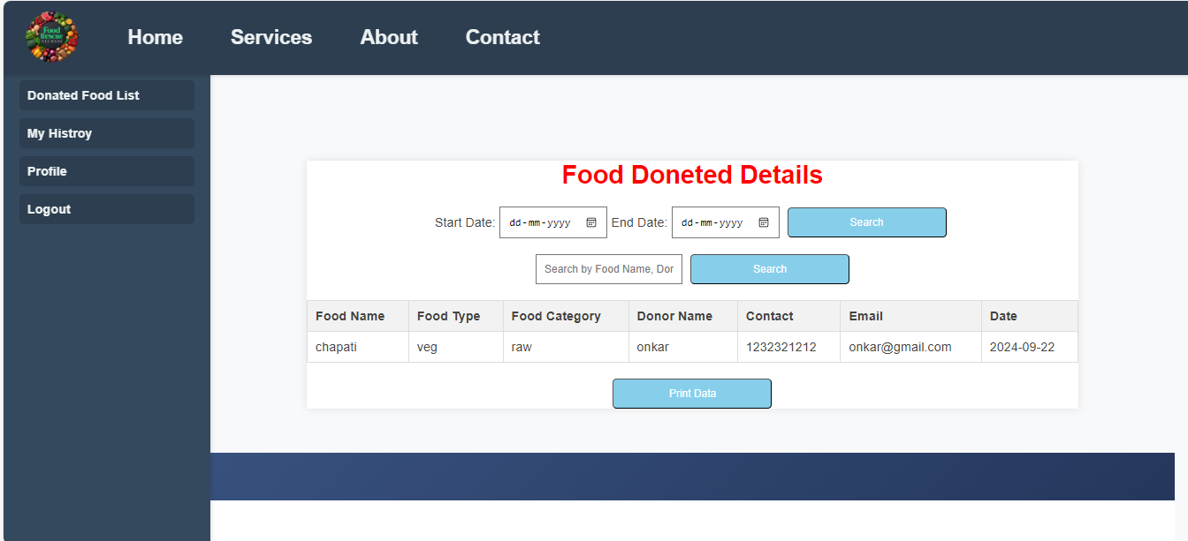
- All Charities in Admin:

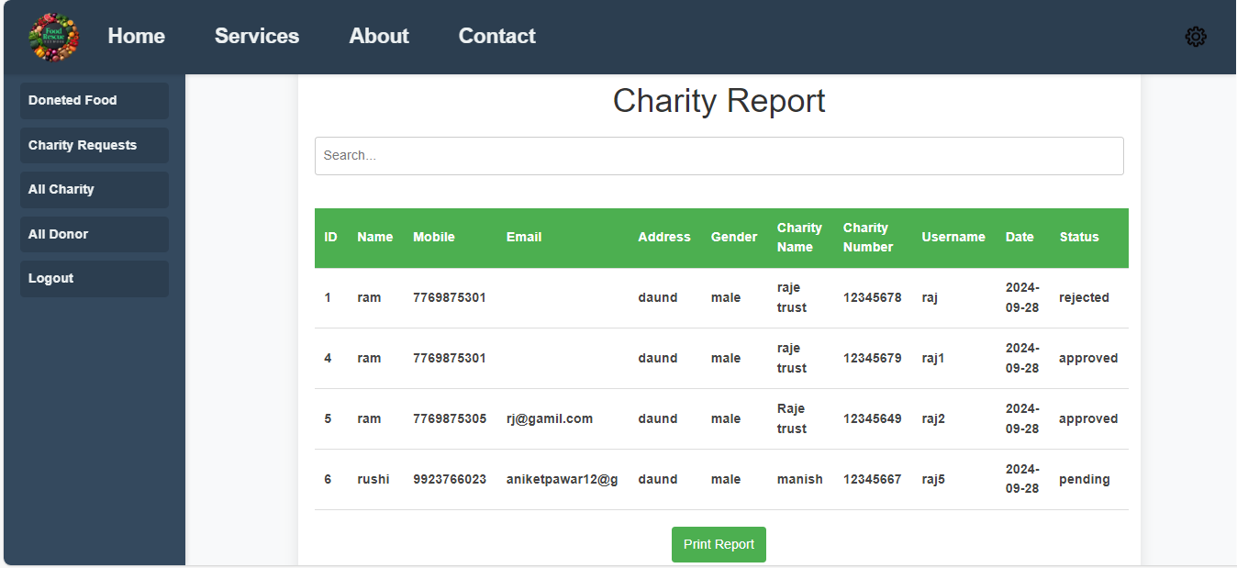
7. Conclusion

The Food Rescue Network project has successfully highlighted the critical need for collaboration in addressing food waste and hunger. By connecting food donors, organizations, and volunteers, we have created a sustainable system that not only minimizes food surplus but also ensures that nutritious meals reach those in need. Our efforts have fostered community engagement, raised awareness about food insecurity, and demonstrated the positive impact of resource sharing. Moving forward, we remain committed to expanding our reach, enhancing our processes, and inspiring more individuals and businesses to join the fight against food waste. Together, we can continue to make a significant difference in our communities, promoting a more equitable and sustainable food system for all.
8. Future Enhancement

- Email verification
- Deploy website
- Add money donation system

9. Bibliography

- www.Google.com
- www.chatgpt.com
- www.you.com
- www.w3school.com
- You tube channel: Code with Harry

10. Annexure (Sample Code)

<!DOCTYPE html>
<html lang="en">
<head></head>
<body>
<header id="header" class="fixed-top">
<div class="container d-flex align-items-center">
<h1 class="logo me-auto"><a href="index.html">Food Rescue Network</a></h1>
<nav id="navbar" class="navbar">
<ul>
<li><a class="nav-link scrollto active" href="#hero"><span class="fa fa-home"> Home </span></a></li>
<li><a class="nav-link scrollto" href="#about"><span class="fa fa-info-circle" aria-hidden="true"> About us</span></a></li>
<li><a class="nav-link scrollto" href="#faq"><span class="fa fa-question-circle"> FAQ</span></a></li>
<li class="dropdown">
<a class="nav-link scrollto" href="#" onclick="toggleDropdown()"><span class="fas fa-sign-out-alt"> Login</span></a>
<ul id="loginDropdown" class="dropdown-menu">
<li><a href="donorlogin.php">Donor Login</a></li>
<li><a href="charitylogin.php">Charity Login</a></li>
</ul>
</li>
</ul>
<i class="bi bi-list mobile-nav-toggle"></i>
</nav><!-- .navbar -->
</div>
</header><!-- End Header -->
</body>
</html>

